# Week 2

## Belmont Report

## Olympic Medal Count

## Fighting Bias

## Ethics in Data Collection

# Week 3

## Are Public Policy Professionals Biased

* Policy professionals are those who prepare and implement policy on behalf of elected politicians
* Policies will be more effective when those who design and implement them are able to form accurate beliefs about how the world works and the costs and benefits of different policies
* Objectivity, impartiality, and accuracy are often legal or official requirements
* Procedural safeguards are in place to promote objective and impartial decision making but it is unclear how effective these are
* Economists with certain political preferences cluster in particular fields and departments
* Political ideology, estimated using all the authors’ papers published before the policy-relevant paper was published, predicts the magnitude of an elasticity (i.e., reverse causality is mitigated by using only the papers published prior to the policy relevant paper)
* Ideologically charged questions reduce accuracy in the interpretation of data among development professionals
* Economics majors were significantly more likely to provide the correct answer in both study frames (social science training does help)
* Framing of information affects the perceptions of risk (do you frame in terms of potential risks or rewards)
* People’s risk tolerance increases when taking risk on behalf of others
* 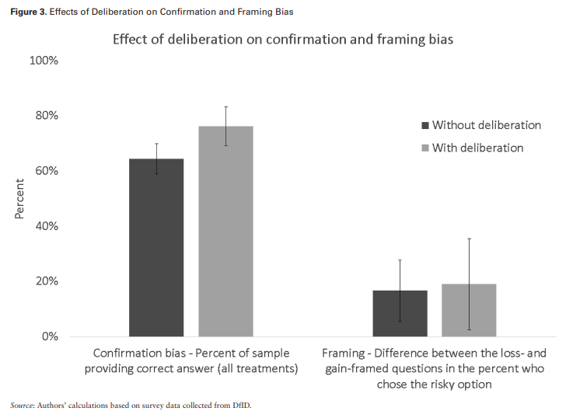
* Psychological processes and social contexts can have dramatic effects on the ways in which policy professionals use and interpret data, make project decisions, and take personal and organizational risks
* Even just being aware of organizational biases could be really helpful

## Excess deaths associated with COVID-19

## Sampling and distributions

* Samples give us a glimpse at the bigger picture, they give us the general shape of the distribution
* Distributions can be distributed or discrete
* Distributions of different samples may be different
* Mean, median, and mode of a normal dist. are the same 🡪 the distribution is symmetric
* Data can be skewed (median is not equal to the mean)
* Data might have 2 or more peaks (bimodal or multimodal)
* Bimodal data can secretly be 2 distributions described as one
* Each value in a uniform distribution has the same frequency
* You can have uniform distributions for things with any number of outcomes, in uniform dist. (like die probability) you’re talking about the “settings of the machine”
* Statistics is about making decisions when we’re not sure

# Week 4

## Is Driver Education Effective

* Pre and post license education by people of all ages led to improvements in secondary outcomes (like performance or small traffic offenses)
* Education was not effective in reducing crashes or injuries at the individual or community level
* Used data from databases (not randomly selected and assigned sample) and a systematic review of existing literature
* Scored methodological quality of each systematic review
* Educational interventions may not always have the intended effect on all individuals
* Implementation method of educational programs can also influence their effectiveness

## Seeing Theory

<https://seeing-theory.brown.edu/frequentist-inference/index.html#section1>

## Limitations of Statistical Significance

* Using the p value as the gold standard of statistical validity is not as reliable as many scientists assume
* Study showed that political moderates saw shades of grey more accurately than did either left-wing or right-wing extremists
* High-profile replication problems have forced scientists to rethink how they evaluate results
* P value was intended to be used as an informal metric
* P value measures whether an observed result can be attributed to chance
  + It cannot answer what the odds that a hypothesis was correct were
* P value of 0.05 is considered “statistically significant”
* We should be asking how much of an effect there is, not is there an effect
* P-hacking is trying multiple things until you get the desired result
* The basic framework of statistics has been virtually unchanged
* One of the strongest protections for scientists is to admit everything

# Week 5

## Does No Pass, No Drive Work?

* Around one third of students in the US fail to graduate from high school every year
* Some states have introduced minimum academic requirements for teenagers to obtain driver’s licenses
* Effects of large-scale financial incentive schemes are relatively small compared to the costs incurred
* NPND laws are large-scale and low-cost negative incentive policies
  + Does this keep kids in school?
  + Does it change their allocation as time between studying, work, and leisure?
* Results indicate that NPND laws have a significantly large effect on educational outcomes among males and blacks, but not among females
* NPD laws were effective in reducing truancy and increased time allocated to homework at the expense of leisure and employment activities
* Historically there was anecdotal evidence that these licenses had been revoked
* Performance of financial incentives vary between demographics and ability
* Incentives linked to inputs improved students more than incentives linked conditional to performance
* There are ethical issues with policies that penalize one group of students
* NPND seems to have larger positive effects among black males than similar policies previously analyzed
* In most states, students can appeal for exemption based on personal reasons
* Used ACS survey data
* Checked different things that could contribute to policy endogeneity
* They used historical data and also “monitored the future”
* An important negative consequence of the law would be that it may encourage teenagers to drive with or without licenses

## What is a dummy variable?

# Week 6

## Stereotype Threat and the Student-Athlete

* Achievement gaps may reflect the cognitive impairment thought to occur in evaluative settings (e.g., classrooms) where a stereotyped identity is salient (i.e., stereotype threat)
* social-identity manipulation reduced the test-score performance of athletes relative to non-athletes by 12%
  + negative performance effects were concentrated among male student-athletes who also responded to the social-identity manipulation by attempting to answer more questions
* Stereotype threat refers to the perceived risk of confirming, through one’s behavior or outcomes, negative stereotypes that are held about one’s social identity
* the salient feature of stereotype threat is the apprehension and diminished cognitive performance that may be created by the suspicion about how one is viewed by others
* effect of stereotype threat on athletes was uniformly negative and led to as much as a 12% reduction in mean performance (1 standard dev)
* SAT scores strongly predicted test performance and that the female participants tended to perform somewhat worse
* Female student-athletes would be particularly harmed by stereotype threat if they have strong academic identities that are susceptible to negative stereotypes

# Week 7